**Rock Climbing Development Instructor assessment course notes**

**Introduction**

The [Rock Climbing Development Instructor](http://www.mountain-training.org/climbing/awards/rock-climbing-instructor) qualification enables experienced instructors to develop a participant’s rock climbing proficiency on single pitch crags in the UK and Ireland. This development may extend to lead climbing.

A qualified Rock Climbing Development Instructor can:

• Develop individuals to lead rock climbs in a single pitch environment using leader

placed (traditional climbing) and equipped (sport climbing) protection.

The training course is an opportunity for you to develop your competence in all areas of the syllabus.

Training will involve a minimum of 32 hours contact time delivered over a minimum of 4 days.

Mountain Training aims to inspire, enable and develop people in walking, climbing and mountaineering through the provision of nationally and internationally recognised skills training and leadership qualifications. All Mountain Training courses are quality assured.

[Mountain Training: Our Ethos](https://www.youtube.com/watch?v=PzqVFu7N-RA)

**Prerequisites for the Rock Climbing Development Instructor assessment course**

Before you book onto a Rock Climbing Development Instructor assessment course:

* You must have completed a Rock Climbing Development Instructor training course.
* You must be familiar with the syllabus.
* You must have physically attended and completed (i.e. not online) a first aid course which involved at least two full days or sixteen hours of instruction and included an element of assessment.

Post training and before presenting yourself for assessment:

* You must have logged a minimum of 10 rock climbing teaching days with students at a variety of outdoor venues.
* You must have led a minimum of 30 single pitch routes using leader placed protection in three different climbing areas at VS 4c or above and recorded them in DLOG. You may include full multi-pitch routes using leader placed protection (up to 50% of the requirement).
* You must have led a minimum of 30 sport climbs in three different climbing areas at 6a or above and recorded them in DLOG. Up to 50% of this experience can be outside the UK and Ireland.

**Please ensure that you have entered the minimum prerequisites in your digital logbook (DLOG) at the time of confirming your place on the assessment course.**

**Rock Climbing Development Instructor course content**

The course will cover the Rock Climbing Development Instructor syllabus which includes the following areas:

Technical competence

* Equipment
* Anchors
* Belaying
* Personal skills
* Background knowledge

Management and Decision Making

* Instructor responsibilities
* Leadership and decision-making
* Knowledge and demonstration of techniques
* Personal safety
* Hazards and emergency procedures

Teaching and Learning Skills

The climbing environment

* Access
* Conservation
* Etiquette and ethics

Detailed information on each of the above topics can be found in the [Rock Climbing Development Instructor Handbook](https://www.mountain-training.org/media/axrjwwt5/rock-climbing-development-instructor-candidate-handbook-jan25.pdf) and the onus is on you to be competent in all of them by the time you come to assessment.

**Potential outcomes of assessment**

Following the assessment the course director will complete a course report on CMS which will record one of three possible results:

***Pass:*** Awarded where the candidate has demonstrated appropriate knowledge and application of the course syllabus, and has shown the necessary experience and attributes of a Rock Climbing Instructor.  
  
***Defer:*** *A*warded where the candidate has generally performed well and has shown the necessary experience and attributes, but where complete proficiency has not been attained in certain aspects of the syllabus or where a lack of experience has been identified.  
  
***Fail:***Awarded where the candidate’s performance has been generally weak, or the necessary experience and attributes have not been shown. A complete assessment course will need to be subsequently attended.

When a candidate's performance merits a defer or fail result the candidate will have a formal written report containing individualised feedback. All relevant information will be included to support the deferred/failed candidate and the assessor who conducts the reassessment.

**Open access to courses**

Mountain Training is committed to ensuring that everyone has equal opportunity to attend our courses. If you have a particular need that requires extra assistance, please discuss it with Mountain Training or your provider.

[More information can be found here](https://www.mountain-training.org/help/resources/support-for-people-with-additional-needs)

**Sustainable Transport**

Mountain Training recognises that climbing, hill walking and mountaineering impact on the environment, and acknowledges the responsibility to take reasonable measures to safeguard the environment for both the present and future generations. We therefore ask participants to consider sustainable transport to access courses.

[The BMC Community Liftshare site](https://thebmc.co.uk/bmcs-launches-lift-share-site)

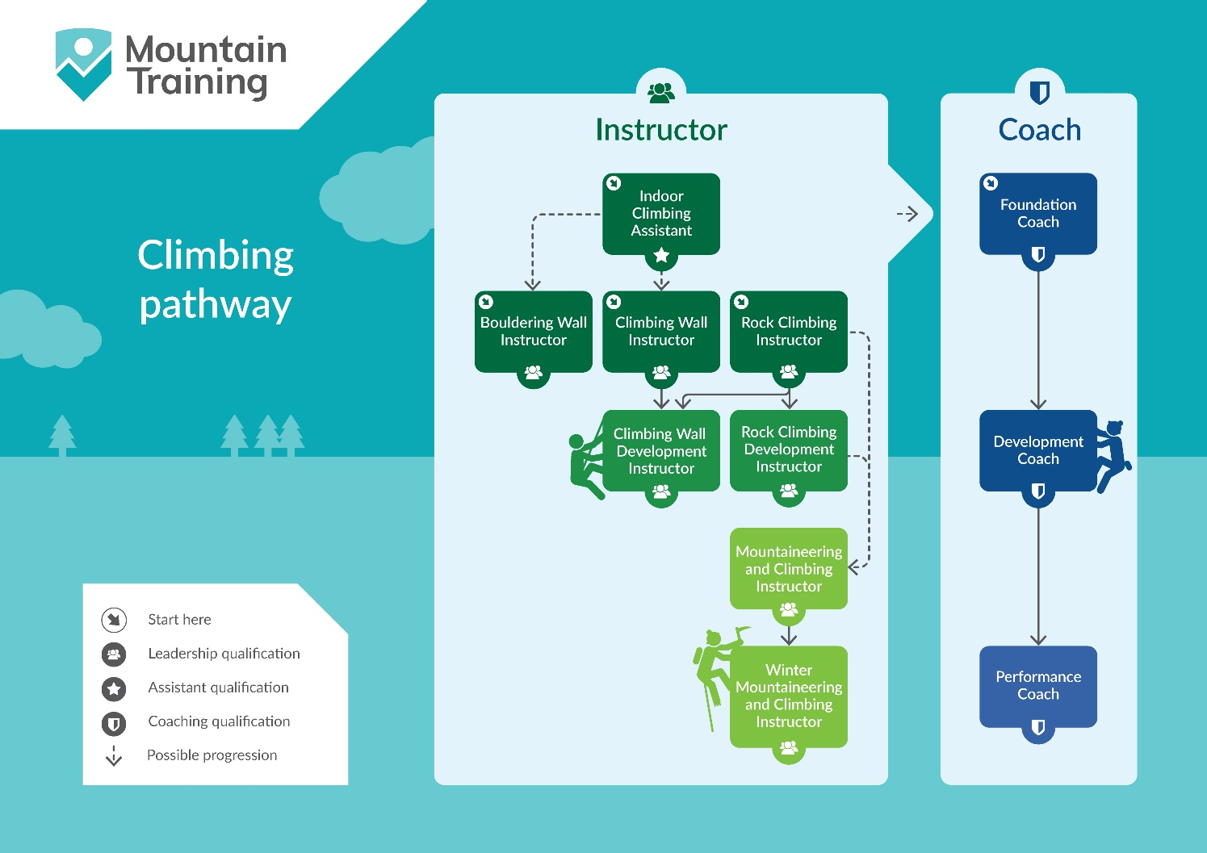

**Insurance**

Mountain Training recommends that you consider personal accident and cancellation insurance. If you already have insurance cover, check that it covers you for the activity you are undertaking.

**Partnerships**[Mountain Training Association](http://www.mountain-training.org/associations/mountain-training-association) - The Mountain Training Association is a membership community that provide members with support and development opportunities, mentoring, resources, workshops and events to help those working towards their qualification, and keep skills and knowledge current for those already qualified.

[British Mountaineering Council](https://www.thebmc.co.uk/bmc-memorandum-and-articles-of-association) - The British Mountaineering Council (BMC) is the national representative body for England and Wales that exists to protect the freedoms and promote the interests of climbers, hill walkers and mountaineers.