Rock Skills: Intermediate

Mountain Training’s two-day Rock Skills Intermediate course is ideal for climbers who want to develop past the basics. The main aims of this course are to learn how to be a safe belayer, how to second routes competently and how to belay a lead climber. You will develop your climbing movement skills and learn how to place protection and construct belays.

Mountain Training aims to inspire, enable and develop people in walking, climbing and mountaineering through the provision of nationally and internationally recognised skills training and leadership qualifications. All Mountain Training courses are quality assured.

Mountain Training: Our Ethos

How to book onto a course
To attend a Rock Skills Intermediate course, you will need:
- To be at least 12 years old.
- Completed a Rock Skills Introduction course OR
- Have logged 10 routes on walls or outdoor crags; and have logged 10 belays of a fellow climber.

We will register you with Mountain Training prior to the course so you can be credited with attendance. If you’ve already got an account on Mountain Training’s Candidate website, please share your ID number with us on booking.

Digital logbook (DLOG)
Once you have been registered onto the scheme you will have access to an account with Mountain Training which includes a digital logbook (DLOG). Here you can log personal climbing days, it’s a great way of storing all of your outdoor experience in one place.

If you need help connecting to your account, information can be found here: Connect with your account
If you have any questions about adding entries: DLOG FAQs

Rock Skills Intermediate - course content

The Rock Skills Intermediate syllabus covers the following aspects:

1. Background and Planning
2. Climbing Skills
3. Footwear and Equipment
4. Technical skills
5. Environmental Knowledge
6. Hazards and Emergency Procedures

Access to courses
Mountain Training is committed to ensuring that everyone has equal opportunity to attend our courses. If you have a particular need that requires extra assistance, please discuss it with Mountain Training or your provider. More information can be found here

Sustainable Transport
Mountain Training recognises that climbing, hill walking and mountaineering impact on the environment, and acknowledges the responsibility to take reasonable measures to safeguard the environment for both the present and future generations. We therefore ask participants to consider sustainable transport to access courses. The BMC Community Liftshare site

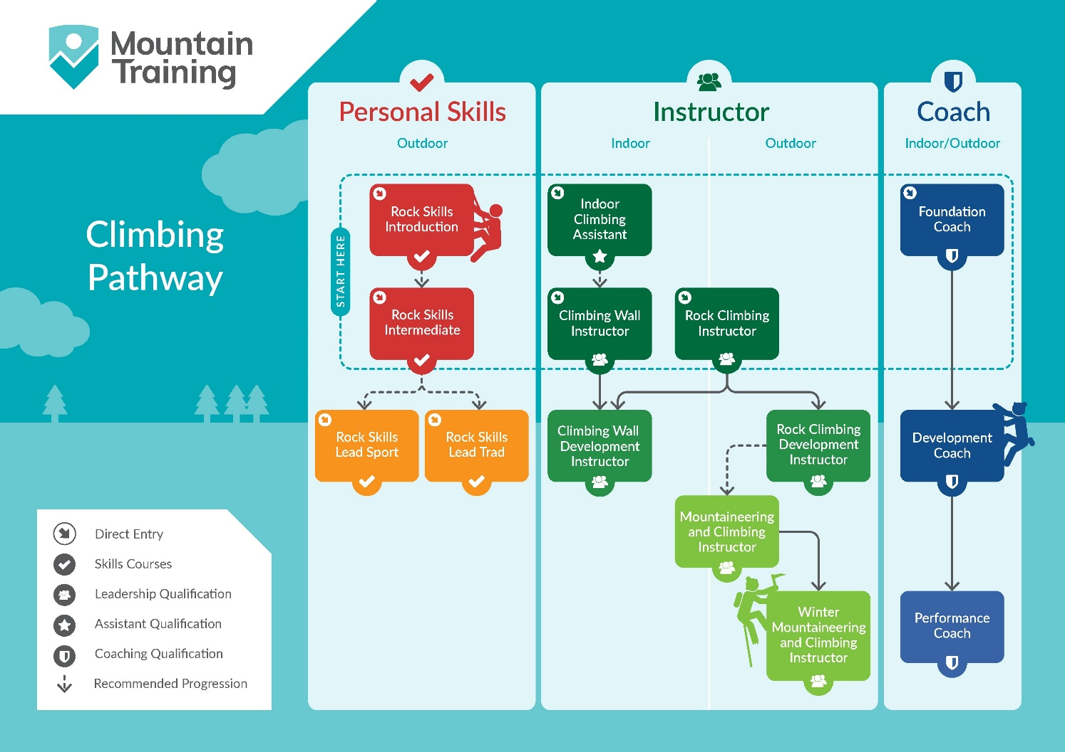

Partnerships
Cotswold Outdoors and their partner brand Snow & Rock are the “Official Skills Partner” of the Mountain Training skills courses. They promote our skills schemes to a wide audience as well as support participants with kit advice (follow link above) and a 15% discount instore and online.

British Mountaineering Council - The British Mountaineering Council (BMC) is the national representative body for England and Wales that exists to protect the freedoms and promote the interests of climbers, hill walkers and mountaineers.

Insurance
Mountain Training recommends you consider personal accident and cancellation insurance. If you already have insurance cover, check that it covers you for the activity you are undertaking.

