**Bouldering Wall Instructor training course notes**

**Introduction**

[Bouldering Wall Instructors](https://www.mountain-training.org/qualifications/climbing/bouldering-wall-instructor/) deliver bouldering sessions on artificial bouldering walls. They are able to teach bouldering skills and manage groups safely.

It is ideal for bouldering wall staff, young people who’ve completed NICAS Bouldering Level 4 or 5, people who run bouldering sessions on artificial walls or towers. This is a one-day course (7 hours).

Mountain Training aims to inspire, enable and develop people in walking, climbing and mountaineering through the provision of nationally and internationally recognised skills training and leadership qualifications. All Mountain Training courses are quality assured.

[Mountain Training: Our Ethos](https://www.youtube.com/watch?v=PzqVFu7N-RA)

**Prerequisites for the Bouldering Wall Instructor training course**

Before you book onto a Climbing Wall Instructor training course;

* You must be registered on the Bouldering Wall Instructor qualification
* You must have recorded (ideally on DLOG*):
  + Visits to three different indoor/artificial bouldering walls on at least 15 different occasions; this must include at least one major public bouldering centre.
  + Personal bouldering at V2 or above

**Please ensure you have entered your minimum prerequisites in your digital logbook (DLOG) at the time of confirming your place on the training course.**

**Bouldering Wall Instructor course content**

The course follows the Bouldering Wall Instructor syllabus. A typical training course will cover the following areas:

Technical competence

* Personal bouldering skills
* Background knowledge

Management and Decision Making

* Instructor responsibilities
* Leadership and decision-making
* Knowledge and demonstration of techniques
* Hazards and emergency procedures
* Management / supervising other staff

Teaching and Learning Skills

The bouldering wall environment

* Etiquette and ethics

Detailed information on each of the above topics can be found in the [Bouldering Wall Instructor handbook](https://www.mountain-training.org/media/iosl1rot/bouldering-wall-instructor-candidate-handbook-may-2025.pdf) and the onus is on you to be competent in all of them by the time you come to assessment.

**Potential outcomes of training**

Following training, a course report will be completed. The results you can achieve are:

*Completed:* You have attended and completed the training course and met the prerequisite requirements.

*Not yet completed:* If for any reason you do not complete the required hours for a course you will receive this result. In all cases an action plan will be discussed and created for you. Providers have up to 21 days to submit a course report, which allows for you to submit further information if necessary, for example if you have not fully met the prerequisite requirements.

**Candidates are reminded that attendance on a training course must not in any way be considered a qualification in its own right. This is only achieved by passing the Climbing Wall Instructor assessment.**

**Open access to courses**

Mountain Training is committed to ensuring that everyone has equal opportunity to attend our courses. If you have a particular need that requires extra assistance, please discuss it with Mountain Training or your provider.

[More information can be found here](https://www.mountain-training.org/help/resources/support-for-people-with-additional-needs)

**Sustainable Transport**

Mountain Training recognises that climbing, hill walking and mountaineering impact on the environment, and acknowledges the responsibility to take reasonable measures to safeguard the environment for both the present and future generations. We therefore ask participants to consider sustainable transport to access courses.

[The BMC Community Liftshare site](https://thebmc.co.uk/bmcs-launches-lift-share-site)

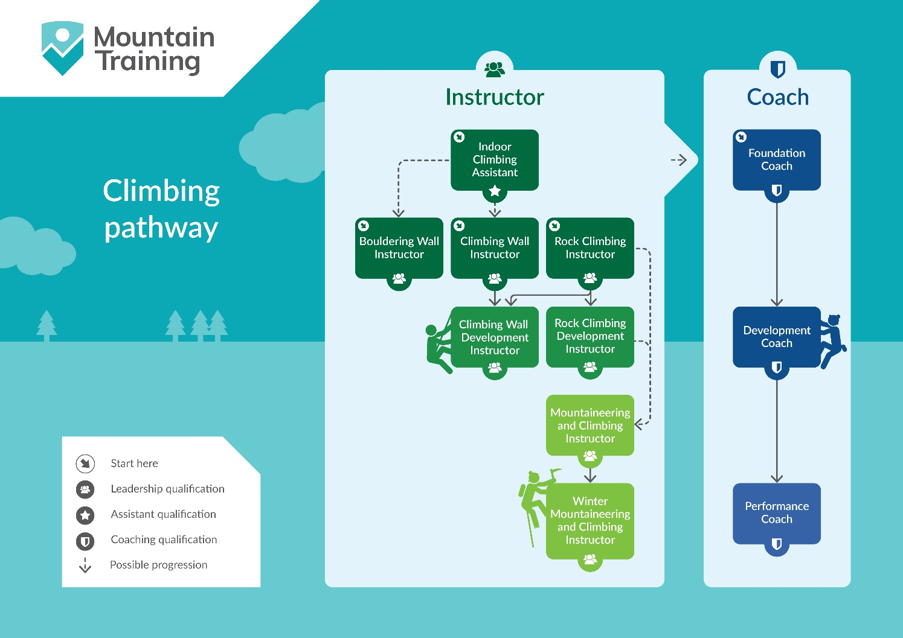

**Insurance**

Mountain Training recommends that you consider personal accident and cancellation insurance. If you already have insurance cover, check that it covers you for the activity you are undertaking.

**Partnerships**[Mountain Training Association](http://www.mountain-training.org/associations/mountain-training-association) - The Mountain Training Association is a membership community that provide members with support and development opportunities, mentoring, resources, workshops and events to help those working towards their qualification, and keep skills and knowledge current for those already qualified.

[British Mountaineering Council](https://www.thebmc.co.uk/bmc-memorandum-and-articles-of-association) - The British Mountaineering Council (BMC) is the national representative body for England and Wales that exists to protect the freedoms and promote the interests of climbers, hill walkers and mountaineers.