**Bouldering Wall Instructor assessment course notes**

**Introduction**

[Bouldering Wall Instructors](https://www.mountain-training.org/qualifications/climbing/bouldering-wall-instructor/) deliver bouldering sessions on artificial bouldering walls. They are able to teach bouldering skills and manage groups safely.

It is ideal for bouldering wall staff, young people who’ve completed NICAS Bouldering Level 4 or 5, people who run bouldering sessions on artificial walls or towers. This is a one-day course (minimum 3 hours contact time).

Mountain Training aims to inspire, enable and develop people in walking, climbing and mountaineering through the provision of nationally and internationally recognised skills training and leadership qualifications. All Mountain Training courses are quality assured.

[Mountain Training: Our Ethos](https://www.youtube.com/watch?v=PzqVFu7N-RA)

**Prerequisites for the Bouldering Wall Instructor assessment course**

Before you book onto a Bouldering Wall Instructor assessment course;

* You must be at least 18 years old.
* You must have attended a Bouldering Wall Instructor training course or have been granted exemption from training.
* You must be familiar with the syllabus.
* You must boulder proficiently at V2.
* You must have assisted in the supervision of at least 10 instructed sessions on at least two different indoor/artificial bouldering venues, including a large public facility. A session is a minimum of an hour and instructors may hold a Mountain Training qualification or a site-specific sign off.
* At least five of these sessions must have [Personal Reflective Comments](https://www.mountain-training.org/help/faqs/cms-and-dlog) recorded on DLOG.
* You must hold a current first aid certificate which involved at least one day and an element of assessment.

**Please ensure that you have entered the minimum prerequisites in your digital logbook (DLOG) at the time of confirming your place on the assessment course.**

**Bouldering Wall Instructor course content**

The course follows the Bouldering Wall Instructor syllabus. A typical assessment course will cover the following areas:

Technical competence

* Personal bouldering skills
* Background knowledge

Management and Decision Making

* Instructor responsibilities
* Leadership and decision-making
* Knowledge and demonstration of techniques
* Hazards and emergency procedures
* Management / supervising other staff

Teaching and Learning Skills

The bouldering wall environment

* Etiquette and ethics

Detailed information on each of the above topics can be found in the [Bouldering Wall Instructor handbook](http://www.mountain-training.org/Content/Uploaded/Downloads/MLT/11aa9095-873b-46ed-90d8-bfe2229602ee.pdf) and the onus is on you to be competent in all of them by the time you come to assessment.

**Potential outcomes of assessment**

Following the assessment the course director will complete a course report on CMS which will record one of three possible results:

***Pass:*** Awarded where the candidate has demonstrated appropriate knowledge and application of the course syllabus, and has shown the necessary experience and attributes of a Climbing Wall Instructor.  
  
***Defer:*** *A*warded where the candidate has generally performed well and has shown the necessary experience and attributes, but where complete proficiency has not been attained in certain aspects of the syllabus or where a lack of experience has been identified.  
  
***Fail:***Awarded where the candidate’s performance has been generally weak, or the necessary experience and attributes have not been shown. A complete assessment course will need to be subsequently attended.

When a candidate's performance merits a defer or fail result the candidate will have a formal written report containing individualised feedback. All relevant information will be included to support the deferred/failed candidate and the assessor who conducts the reassessment.

**Open access to courses**

Mountain Training is committed to ensuring that everyone has equal opportunity to attend our courses. If you have a particular need that requires extra assistance, please discuss it with Mountain Training or your provider.

[More information can be found here](https://www.mountain-training.org/help/resources/support-for-people-with-additional-needs)

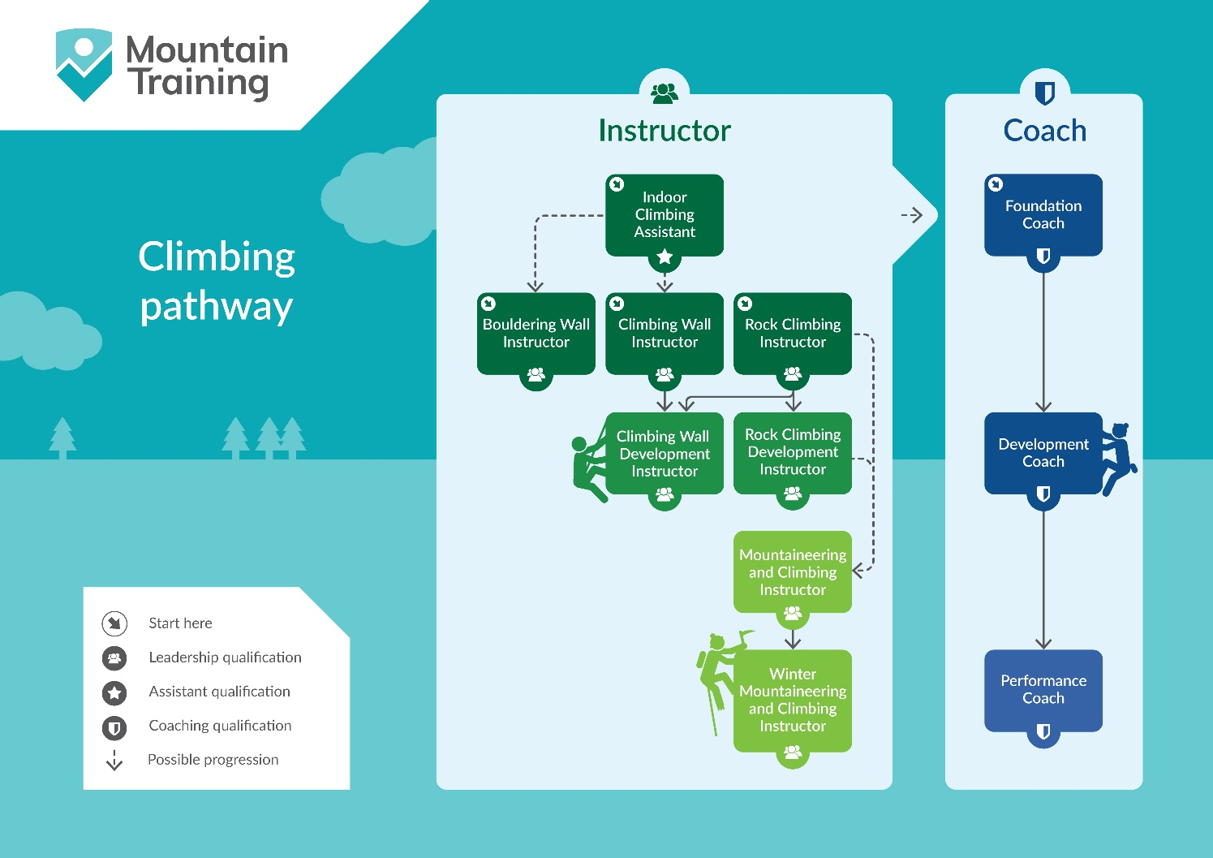

**Sustainable Transport**

Mountain Training recognises that climbing, hill walking and mountaineering impact on the environment, and acknowledges the responsibility to take reasonable measures to safeguard the environment for both the present and future generations. We therefore ask participants to consider sustainable transport to access courses.

[The BMC Community Liftshare site](https://thebmc.co.uk/bmcs-launches-lift-share-site)

**Insurance**

Mountain Training recommends that you consider personal accident and cancellation insurance. If you already have insurance cover, check that it covers you for the activity you are undertaking.

**Partnerships**[Mountain Training Association](http://www.mountain-training.org/associations/mountain-training-association) - The Mountain Training Association is a membership community that provide members with support and development opportunities, mentoring, resources, workshops and events to help those working towards their qualification, and keep skills and knowledge current for those already qualified.

[British Mountaineering Council](https://www.thebmc.co.uk/bmc-memorandum-and-articles-of-association) - The British Mountaineering Council (BMC) is the national representative body for England and Wales that exists to protect the freedoms and promote the interests of climbers, hill walkers and mountaineers.