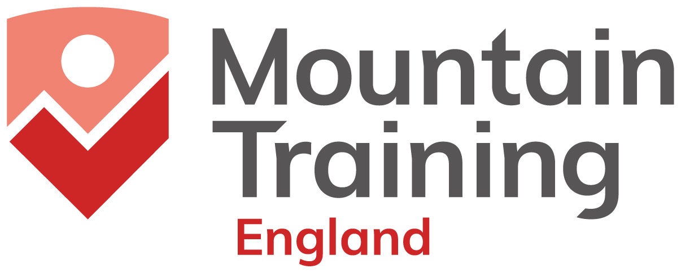

MTE Disability Training Fund Application Form
Return completed form to rich@mountain-training.org

Information for applicants
Mountain Training qualifications train and assess people in the skills required to lead others in various types of UK countryside as well as supervising and instructing climbing.
- You must be registered on the qualification you are applying for at the time of application for funding.
- You must have recorded in DLog the required minimum experience necessary to undertake the course you are applying for support to attend.
- You must book and pay for the course. If funding is granted MTE will reimburse you half the median course cost on confirmation of completion of the course.
- Applications must be submitted to MTE at least six weeks prior to the course start date.
- This fund is intended to support and enable people with disabilities to become qualified to lead groups safely in climbing and hillwalking activities.
- MTE will fund 50% of the median course fee.
Who can apply for support?
Applications are accepted from people with disabilities. Please see Eligibility Criteria here: https://www.mountain-training.org/help/support/funding-for-qualifications/mountain-training-england-disability-training-fund/

This support is available for people who otherwise wouldn’t be able to afford to access our courses. You are asked to sign the Declaration of Need in this form.

How to make an application for funding

- Complete page 3 and 4 of this form.
- Sign the Declaration of Need for support
- Ask your training provider to sign page 4 in support of your application. Applications that are not endorsed by a training provider will not be considered.
- Send the completed form to rich@mountain-training.org

MTE reserves the right to make the final decision. Funding will be granted according to need. Please ensure you are clear in the form about why you believe we should fund your course. The information you give in You and Your Aims should be sufficient for us to make this decision.

What happens next?

MTE’s Funding Committee will screen your application and make a decision as to whether we will fund you to attend a course.

- If we decline your application we will write to you to inform you of our reasons.
- If we grant your application we will inform you and send you a claim form and a feedback form.
- When you have attended the course you will complete the claim form and the course evaluation and forward them to cath@mountain-training.org.
- MTE will reimburse up to 50% of the median course fee.
- MTE will contribute to the cost of a personal assistant support or teaching/ learning support during the course (capped at £150 per candidate per course)
MTE Disability Training Fund Application

YOU
Your full name
Your MTID
Your location | UK County:
Your location | UK Post Code:
Your email address
Your ethnicity
Your gender: Man/ Woman/ Non-Binary/ Transman/ Transwoman/ Prefer Not to Say
Your disability

YOUR AIMS
Why do you want to take up this opportunity?
How does disability affect you in accessing the outdoors? How does disability affect your access to training and education?
Do you already attend a walking or climbing group?
Please describe the group’s members and regular activities. If the group has a name please tell us what it is.
What is your role in the group?
How long have you been involved with the group?
How will your group benefit if you gain one of the Mountain Training Awards?

THE QUALIFICATION or SKILLS COURSE –the name of the qualification or skills course you would like support with.
e.g. Mountain Leader or
Hill Skills
Dates of your course

5. Amount of funding applied for.
- You may apply for up to 50% of the median course cost for each course you wish to attend.
- You may also apply for a contribution towards the cost of a personal assistant support or teaching/ learning support during the course (capped at £150 per candidate per course)
Course cost  Personal assistant support (please describe needs)  Teaching and learning support (please describe needs)  Other (please describe needs) | Median course cost (see table below): £  50% of median course cost: £

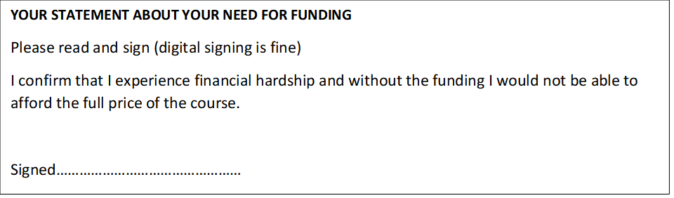

To be endorsed by the training provider:
I, the undersigned being the training provider, believe the above information to be accurate and support the application of (candidate name) for funding.
Name:………………………………………………………………………………………………..Date: ……………………………….

Provider Name (if different)…………………………………………………………………………………………
Median Course Costs
MTE course providers set their own course delivery costs (https://www.mountain-training.org/find-a-course). Course costs vary depending on whether courses are residential or non-residential. With the aim of making access to funding as equitable as possible we award up to 50% of the median course cost. Median course costs are calculated annually.
Course type | Median Course Cost
Hill Skills | £154
Mountain Skills | £147.50
Rock Skills Intro | £80
Rock Skills Intermediate | £205
Rock Skills Learn to Lead SPORT | £220
Rock Skills Learn to Lead TRAD | £255
Indoor Climbing Assistant | £85
Bouldering Wall Instructor Training | £100
Bouldering Wall Instructor Assessment | £75
Climbing Wall Instructor Training | £160
Climbing Wall Instructor Assessment | £110
Climbing Wall Abseil Module Training | £50
Climbing Wall Abseil Module Assessment | £65
Climbing Wall Development Instructor Training | £115
Climbing Wall Development Instructor Assessment | £115
Rock Climbing Instructor Training | £255
Rock Climbing Instructor Assessment | £200
Rock Climbing Development Instructor Training | £410
Rock Climbing Development Instructor Assessment | £400
Foundation Coach Training | £100
Foundation Coach Assessment | £135
Development Coach Training | £170
Development Coach Assessment | £200
Camping Leader | £100
Lowland Leader Training | £165
Lowland Leader Assessment | £180
Hill and Moorland Leader Training | £245
Hill and Moorland Leader Assessment | £265
Mountain Leader Training | £425
Mountain Leader Assessment | £440

Disability Training Fund – Terms & Conditions (please read)
- Competition for the Disability Training Fund is high. It is strongly recommended that applicants familiarise themselves with the content of the course/s that they intend to do: https://www.mountain-training.org/personal-skills
https://www.mountain-training.org/qualifications
- The Disability Training Fund is to support people with disabilities, who are currently under-represented among our candidates because they face barriers to participation, and who would otherwise not have the financial means to engage with our schemes and awards.
- Application may be made for funding for a maximum of two courses per person. The funding requirements must be met and funding will not be granted to the same applicant for the same course.
- Applicants must pay for scheme registration and course bookings (https://www.mountain-training.org/find-a-course ). Courses should be booked and paid for by the applicant and the funding claimed after the course dates. Funding offers are subject to verification checks.
- Incomplete applications will not be considered.
- All data will be held securely, according to GDPR.
- Applications can be made at any time. Decision to grant funding are made by MTE Trustees.
- We aim to respond with a decision within 4 weeks of receipt of application.
- Once granted, the course applied for must be completed within the time frame given on this form and the course evaluation and claim form submitted within two weeks of the course date. Funding will not be held over beyond the time frame given on your application.

Office use only
Application received (date)
Recorded on spreadsheet
Approved/ Declined
Applicant informed
Claim form sent

