Hill and Moorland Leader assessment course notes

Introduction
The Hill and Moorland Leader scheme is designed to train and assess those who wish to lead hill walking groups on day walks in the defined terrain in summer conditions. The Hill and Moorland Leader has been developed from, and succeeds, the Walking Group Leader. The Hill and Moorland Leader assessment course aims to assess the technical skills, judgements and areas of knowledge deemed necessary to ensure an individual is safe to do so. This is a 3 day course (minimum of 30 hours).

Mountain Training aims to inspire, enable and develop people in walking, climbing and mountaineering through the provision of nationally and internationally recognised skills training and leadership qualifications. All Mountain Training courses are quality assured.

Mountain Training: Our Ethos
Learn, Lead, Inspire - Into the Hills

Prerequisites for the Hill and Moorland Leader assessment course
Before you book onto the Hill and Moorland Leader assessment course;
- You must have attended a Hill and Moorland Leader training course (or have been granted exemption).
- You must be familiar with the syllabus
- You must have logged a minimum of 40 Quality Hillwalking Days in at least three different upland areas of the UK and Ireland.
- You must hold a current first aid certificate, minimum 16 hours and relevant to your work as a Hill and Moorland Leader.

Please ensure you have entered your minimum prerequisites in your digital logbook (DLOG) at the time of confirming your place on the assessment course.

Hill and Moorland Leader assessment course content
The course follows the Hill and Moorland Leader syllabus. A typical course will cover the following areas:

- Walking and group management
- Navigation
- Hazards and emergency procedures
- Equipment
- Responsibilities of the leader
- Group management
- Access, conservation, and environmental knowledge
- Weather
- Background Knowledge

Detailed information on each of the above topics can be found in the Hill and Moorland Handbook, and the onus is on you to be competent in all of them by the time you come to assessment.

Potential outcomes of assessment
Following the assessment the course director will complete a course report on CMS which will record one of three possible results:

Pass: Awarded where the candidate has demonstrated appropriate knowledge and application of the course syllabus, and has shown the necessary experience and attributes of a Hill and Moorland Leader.
Defer: Awarded where the candidate has generally performed well and has shown the necessary experience and attributes, but where complete proficiency has not been attained in certain aspects of the syllabus or where a lack of experience has been identified.
Fail: Awarded where the candidate’s performance has been generally weak, or the necessary experience and attributes have not been shown. A complete assessment course will need to be subsequently attended.

When a candidate's performance merits a defer or fail result the candidate will have a formal written report containing individualised feedback. All relevant information will be included to support the deferred/failed candidate and the assessor who conducts the re-assessment.

Access to courses
Mountain Training is committed to ensuring that everyone has equal opportunity to attend our courses. If you have a particular need that requires extra assistance, please discuss it with Mountain Training or your provider.
More information can be found here

Sustainable Transport
Mountain Training recognises that climbing, hill walking and mountaineering impact on the environment, and acknowledges the responsibility to take reasonable measures to safeguard the environment for both the present and future generations. We therefore ask participants to consider sustainable transport to access courses.
The BMC Community Liftshare site

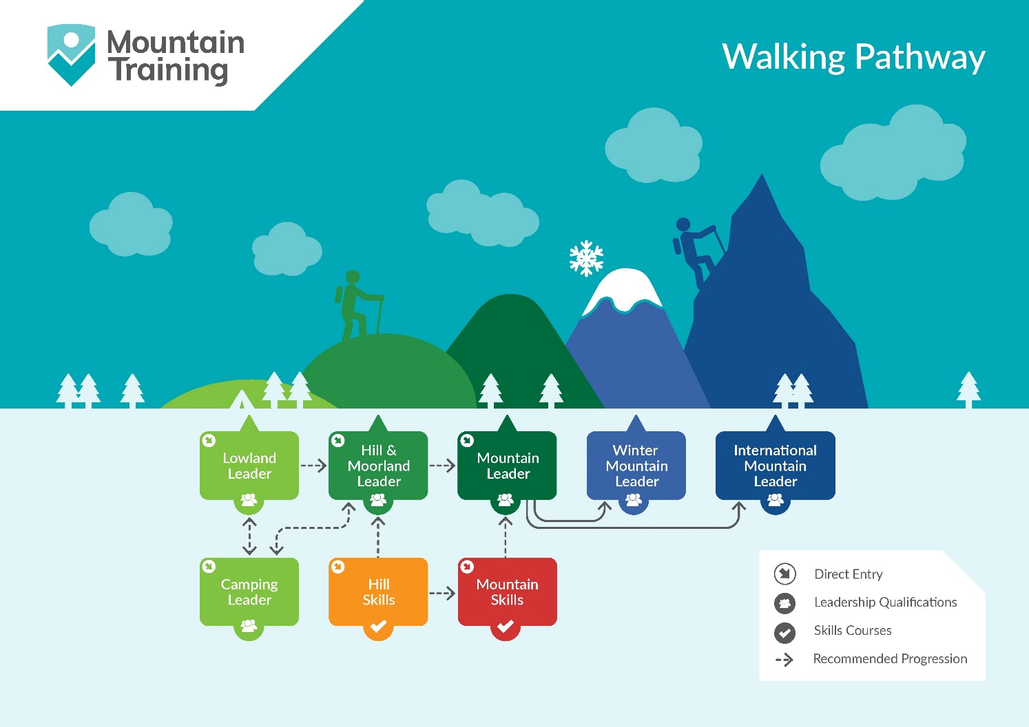

Insurance
Mountain Training recommends that you consider personal accident and cancellation insurance. If you already have insurance cover, check that it covers you for the activity you are undertaking.

Partnerships
Mountain Training Association - The Mountain Training Association is a membership community that provide members with support and development opportunities, mentoring, resources, workshops and events to help those working towards their qualification, and keep skills and knowledge current for those already qualified.

British Mountaineering Council - The British Mountaineering Council (BMC) is the national representative body for England and Wales that exists to protect the freedoms and promote the interests of climbers, hill walkers and mountaineers.

