**Rock Climbing Development Instructor training course notes**

**Introduction**

The [Rock Climbing Development Instructor](http://www.mountain-training.org/climbing/awards/rock-climbing-instructor) qualification enables experienced instructors to develop a participant’s rock climbing proficiency on single pitch crags in the UK and Ireland. This development may extend to lead climbing.

A qualified Rock Climbing Development Instructor can:

• Develop individuals to lead rock climbs in a single pitch environment using leader

placed (traditional climbing) and equipped (sport climbing) protection.

The training course is an opportunity for you to develop your competence in all areas of the syllabus.

Training will involve a minimum of 32 hours contact time delivered over a minimum of 4 days.

Mountain Training aims to inspire, enable and develop people in walking, climbing and mountaineering through the provision of nationally and internationally recognised skills training and leadership qualifications. All Mountain Training courses are quality assured.

[Mountain Training: Our Ethos](https://www.youtube.com/watch?v=PzqVFu7N-RA)

**Prerequisites for the Rock Climbing Development Instructor registration**

Before you book onto a Rock Climbing Development Instructor training course, your registration must have been approved, having met the following prerequisites:

* You must be a qualified Rock Climbing Instructor.
* You must have delivered a minimum of 20 days as a Rock Climbing Instructor at a variety of crags and with a variety of climbers, recorded in DLOG.
* You must have led a minimum of 60 named single pitch routes using leader-placed protection in three different climbing areas at VS 4c or above and logged them in DLOG. You may include full multi-pitch routes using leader placed protection (up to 50% of the requirement).
* You must have led a minimum of 60 sport climbs in three different climbing areas at 6a or above and logged them in DLOG.

Up to 50% of this experience can be from outside the UK and Ireland.

**You will not be able to book onto a training course until your registration has been approved by Mountain Training.**

**Rock Climbing Development Instructor course content**

The course will cover the Rock Climbing Development Instructor syllabus which includes the following areas:

Technical competence

* Equipment
* Anchors
* Belaying
* Personal skills
* Background knowledge

Management and Decision Making

* Instructor responsibilities
* Leadership and decision-making
* Knowledge and demonstration of techniques
* Personal safety
* Hazards and emergency procedures

Teaching and Learning Skills

The climbing environment

* Access
* Conservation
* Etiquette and ethics

Detailed information on each of the above topics can be found in the [Rock Climbing Development Instructor Handbook](https://www.mountain-training.org/media/axrjwwt5/rock-climbing-development-instructor-candidate-handbook-jan25.pdf) and the onus is on you to be competent in all of them by the time you come to assessment.

**Potential outcomes of training**

Following training, a course report will be completed. The results you can achieve are:

*Completed:* You have attended and completed the training course and met the prerequisite requirements.

*Not yet completed:* If for any reason you do not complete the required hours for a course you will receive this result. In all cases an action plan will be discussed and created for you. Providers have up to 21 days to submit a course report, which allows for you to submit further information if necessary, for example if you have not fully met the prerequisite requirements.

**Candidates are reminded that attendance on a training course must not in any way be considered a qualification in its own right. This is only achieved by passing the Rock Climbing Development Instructor assessment.**

**Open access to courses**

Mountain Training is committed to ensuring that everyone has equal opportunity to attend our courses. If you have a particular need that requires extra assistance, please discuss it with Mountain Training or your provider.

[More information can be found here](https://www.mountain-training.org/help/resources/support-for-people-with-additional-needs)

**Sustainable Transport**

Mountain Training recognises that climbing, hill walking and mountaineering impact on the environment, and acknowledges the responsibility to take reasonable measures to safeguard the environment for both the present and future generations. We therefore ask participants to consider sustainable transport to access courses.

[The BMC Community Liftshare site](https://thebmc.co.uk/bmcs-launches-lift-share-site)

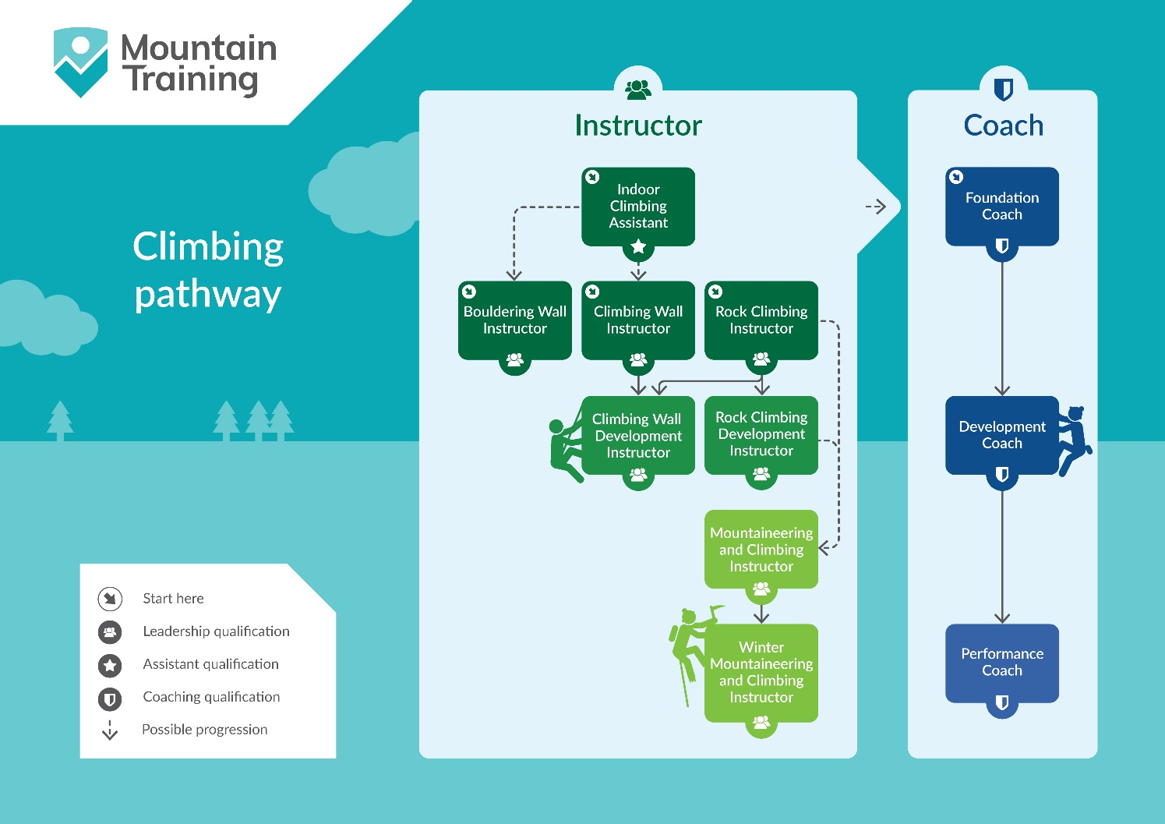

**Insurance**

Mountain Training recommends that you consider personal accident and cancellation insurance. If you already have insurance cover, check that it covers you for the activity you are undertaking.

**Partnerships**[Mountain Training Association](http://www.mountain-training.org/associations/mountain-training-association) - The Mountain Training Association is a membership community that provide members with support and development opportunities, mentoring, resources, workshops and events to help those working towards their qualification, and keep skills and knowledge current for those already qualified.

[British Mountaineering Council](https://www.thebmc.co.uk/bmc-memorandum-and-articles-of-association) - The British Mountaineering Council (BMC) is the national representative body for England and Wales that exists to protect the freedoms and promote the interests of climbers, hill walkers and mountaineers.