Rock Climbing Instructor training course notes

Introduction
The Rock Climbing Instructor scheme enables experienced rock climbers to instruct climbing on single pitch crags and artificial climbing walls and towers.

Within the defined terrain a qualified Rock Climbing Instructor can:
- Teach climbing skills.
- Take people climbing, bouldering and abseiling.
- Manage groups safely in these activities.

The training course is an opportunity for you to develop your competence in all areas of the syllabus.
This is a 3 day course (minimum of 24 hours) with at least 8 hours delivered in a climbing wall.
OR
A 2 day course (minimum 16 hours) for candidates who have attended a Climbing Wall Instructor (or Climbing Wall Award) training or assessment only. All candidates on the 2 day course must have met these criteria.

Mountain Training aims to inspire, enable and develop people in walking, climbing and mountaineering through the provision of nationally and internationally recognised skills training and leadership qualifications. All Mountain Training courses are quality assured.

Mountain Training: Our Ethos

Prerequisites for the Rock Climbing Instructor training course
Before you book onto a Rock Climbing Instructor training course;
- You must be registered on the scheme
You must have an up to date logbook (preferably DLOG) with evidence of the following:
- 15 led routes which must be graded rock climbs with traditional protection
- 15 led routes at a climbing wall
- 5 led routes which must be outdoor bolt protected sport climbs.

Please ensure you have entered your minimum prerequisites in your digital logbook (DLOG) at the time of confirming your place on the training course.

Rock Climbing Instructor course content
The course will cover the Rock Climbing Instructor syllabus which includes the following areas:

Technical competence
- Equipment
- Anchors
- Belaying
- Personal skills
- Abseiling
- Background knowledge

Management and Decision Making
- Planning and structure of sessions
- Organising sessions
- Management of participants
- Decision Making
- Personal safety
- Knowledge and demonstration of techniques
- Managing/supervising other staff

Teaching and Learning Skills

The climbing environment
- Access
- Conservation
- Etiquette and ethics

Detailed information on each of the above topics can be found in the Rock Climbing Instructor Handbook and the onus is on you to be competent in all of them by the time you come to assessment.

Potential outcomes of training
Following training, a course report will be completed. The results you can achieve are:

Completed: You have attended and completed the training course and met the prerequisite requirements.

Not yet completed: If for any reason you do not complete the required hours for a course you will receive this result. In all cases an action plan will be discussed and created for you. Providers have up to 21 days to submit a course report, which allows for you to submit further information if necessary, for example if you have not fully met the prerequisite requirements.

Candidates are reminded that attendance on a training course must not in any way be considered a qualification in its own right. This is only achieved by passing the Rock Climbing Instructor assessment.

Open access to courses
Mountain Training is committed to ensuring that everyone has equal opportunity to attend our courses. If you have a particular need that requires extra assistance, please discuss it with Mountain Training or your provider.
More information can be found here

Sustainable Transport
Mountain Training recognises that climbing, hill walking and mountaineering impact on the environment, and acknowledges the responsibility to take reasonable measures to safeguard the environment for both the present and future generations. We therefore ask participants to consider sustainable transport to access courses.
The BMC Community Liftshare site

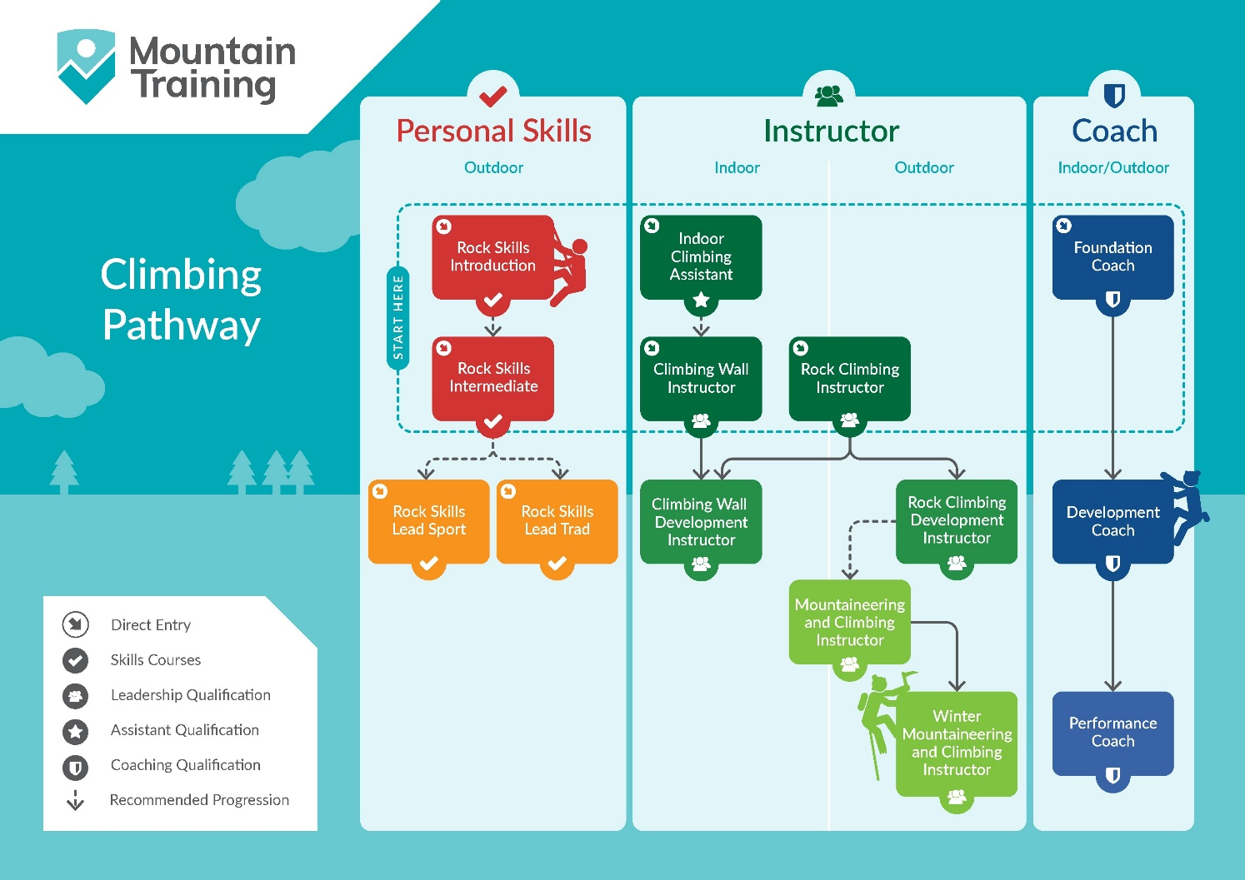
Insurance
Mountain Training recommends that you consider personal accident and cancellation insurance. If you already have insurance cover, check that it covers you for the activity you are undertaking.

Partnerships
Mountain Training Association - The Mountain Training Association is a membership community that provide members with support and development opportunities, mentoring, resources, workshops and events to help those working towards their qualification, and keep skills and knowledge current for those already qualified.

British Mountaineering Council - The British Mountaineering Council (BMC) is the national representative body for England and Wales that exists to protect the freedoms and promote the interests of climbers, hill walkers and mountaineers.

