Mountain Leader training course notes

Introduction
The Mountain Leader scheme was established to promote the safe enjoyment of the hills and mountains. The scheme provides training and assessment in the technical and group management skills required by those who wish to lead groups in the mountains, hills and moorlands of the United Kingdom and Ireland, other than in winter conditions. The Mountain Leader scheme offers the opportunity to gain technical competence in leading walkers in the hills and mountains.

The Mountain Leader training course aims to develop the technical skills, judgements and areas of knowledge deemed necessary to ensure an individual is safe to work within the scope of the award. It does not provide a rock climbing qualification, nor does it cover the skills required for the planned use of a rope. This is a 6 day course (minimum of 60 hours).

Mountain Training aims to inspire, enable and develop people in walking, climbing and mountaineering through the provision of nationally and internationally recognised skills training and leadership qualifications. All Mountain Training courses are quality assured.

Mountain Training: Our Ethos
Learn, Lead, Inspire - Into the Hills

Prerequisites for the Mountain Leader training course
Before you book onto a Mountain Leader training course;
- You must be registered on the scheme
- You must have recorded a minimum of 20 Quality Mountain Days which can have taken place at any point (pre or post registration).

Please ensure you have entered your minimum prerequisites in your digital logbook (DLOG) at the time of confirming your place on the training course.

Mountain Leader training course content
The course will cover the Mountain Leader syllabus which includes the following areas:
- Group management and the responsibilities of the group leader
- Navigation
- Access and the environment
- Hazards (including steep ground and rivers) and emergency procedures
- Equipment
- Expedition skills
- Weather
- Background knowledge

Detailed information on each of the above topics can be found in the Mountain Leader Handbook, and the onus is on you to be competent in all of them by the time you come to assessment.

Potential outcomes
Following training, a course report will be completed. The results you can achieve are:

Completed: You have attended and completed the training course and met the prerequisite requirements.

Not yet completed: If for any reason you do not complete the required hours for a course you will receive this result. In all cases an action plan will be discussed and created for you. Providers have up to 21 days to submit a course report, which allows for you to submit further information if necessary, for example if you have not fully met the prerequisite requirements.

Candidates are reminded that attendance on a training course must not in any way be considered a qualification in its own right. This is only achieved by passing the Mountain Leader assessment.

Access to courses
Mountain Training is committed to ensuring that everyone has equal opportunity to attend our courses. If you have a particular need that requires extra assistance, please discuss it with Mountain Training or your provider.
More information can be found here

Sustainable Transport
Mountain Training recognises that climbing, hill walking and mountaineering impact on the environment, and acknowledges the responsibility to take reasonable measures to safeguard the environment for both the present and future generations. We therefore ask participants to consider sustainable transport to access courses.
The BMC Community Liftshare site

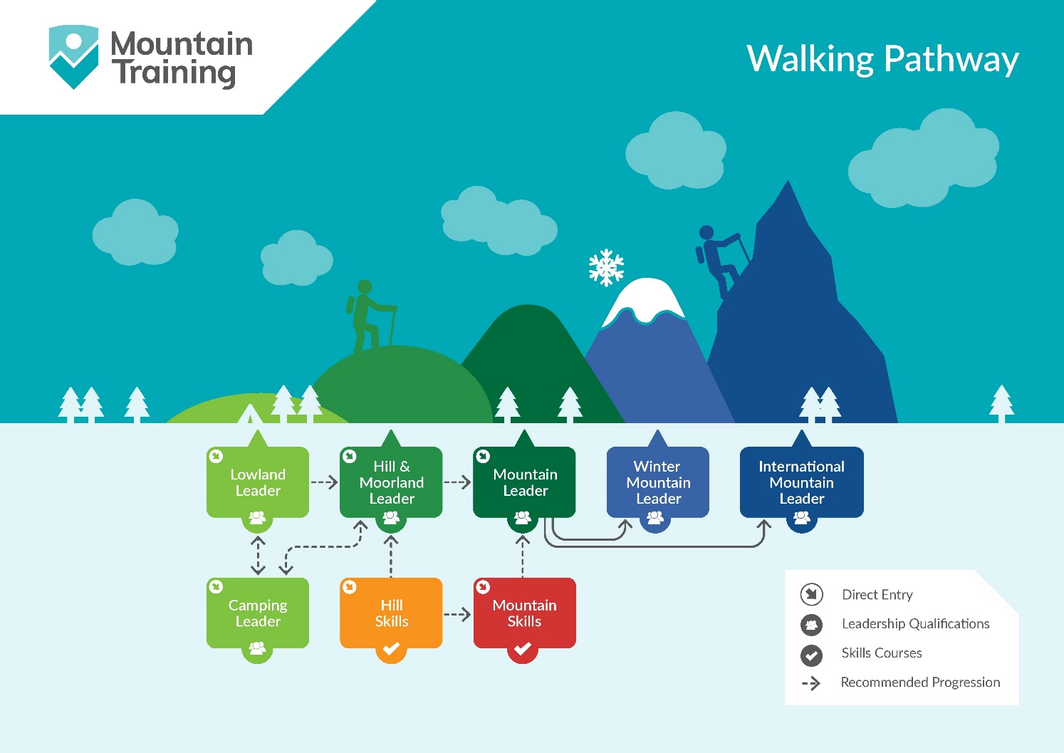

Insurance
Mountain Training recommends that you consider personal accident and cancellation insurance. If you already have insurance cover, check that it covers you for the activity you are undertaking.

Partnerships
Mountain Training Association - The Mountain Training Association is a membership community that provide members with support and development opportunities, mentoring, resources, workshops and events to help those working towards their qualification, and keep skills and knowledge current for those already qualified.

British Mountaineering Council - The British Mountaineering Council (BMC) is the national representative body for England and Wales that exists to protect the freedoms and promote the interests of climbers, hill walkers and mountaineers.

