**Climbing Wall Instructor training course notes**

**Introduction**

The [Climbing Wall Instructor](https://www.mountain-training.org/qualifications/climbing/qualifications/climbing-wall-instructor) gives climbers the skills required to supervise participants on purpose built artificial climbing walls and boulders.

It is ideal for people who work at climbing walls or at venues with permanent or mobile climbing towers. There is also an optional Abseil Module (often run in conjunction with the Climbing Wall Instructor) which is all about supervising abseiling in climbing walls. This is a two day course (12 hours).

Mountain Training aims to inspire, enable and develop people in walking, climbing and mountaineering through the provision of nationally and internationally recognised skills training and leadership qualifications. All Mountain Training courses are quality assured.

[Mountain Training: Our Ethos](https://www.youtube.com/watch?v=PzqVFu7N-RA)

**Prerequisites for the Climbing Wall Instructor training course**

Before you book onto a Climbing Wall Instructor training course;

* You must be registered on the scheme.
* You must have an understanding of the wider sport of climbing.

You must have an up to date logbook (preferably DLOG) with evidence of the following:

* Visits to 3 different climbing walls on at least 15 different occasions; this must include at least one major public wall.
* 10 led routes at Fr 4 on walls.

**Please ensure you have entered your minimum prerequisites in your digital logbook (DLOG) at the time of confirming your place on the training course.**

**Climbing Wall Instructor course content**

The course follows the Climbing Wall Instructor syllabus. A typical training course will cover the following areas:

Technical competence

* Equipment
* Belaying
* Personal climbing skills
* Background knowledge

Management and Decision Making

* Planning and structure of sessions
* Management of participants
* Decision Making
* Knowledge and demonstration of techniques
* Management of other staff

Teaching and Learning Skills

The climbing wall environment

* Access
* Etiquette and ethics

Detailed information on each of the above topics can be found in the [Climbing Wall Instructor handbook](http://www.mountain-training.org/Content/Uploaded/Downloads/MLT/11aa9095-873b-46ed-90d8-bfe2229602ee.pdf) and the onus is on you to be competent in all of them by the time you come to assessment.

**Potential outcomes of training**

Following training, a course report will be completed. The results you can achieve are:

*Completed:* You have attended and completed the training course and met the prerequisite requirements.

*Not yet completed:* If for any reason you do not complete the required hours for a course you will receive this result. In all cases an action plan will be discussed and created for you. Providers have up to 21 days to submit a course report, which allows for you to submit further information if necessary, for example if you have not fully met the prerequisite requirements.

**Candidates are reminded that attendance on a training course must not in any way be considered a qualification in its own right. This is only achieved by passing the Climbing Wall Instructor assessment.**

**Open access to courses**

Mountain Training is committed to ensuring that everyone has equal opportunity to attend our courses. If you have a particular need that requires extra assistance, please discuss it with Mountain Training or your provider.

[More information can be found here](https://www.mountain-training.org/help/resources/support-for-people-with-additional-needs)

**Sustainable Transport**

Mountain Training recognises that climbing, hill walking and mountaineering impact on the environment, and acknowledges the responsibility to take reasonable measures to safeguard the environment for both the present and future generations. We therefore ask participants to consider sustainable transport to access courses.

[The BMC Community Liftshare site](https://thebmc.co.uk/bmcs-launches-lift-share-site)

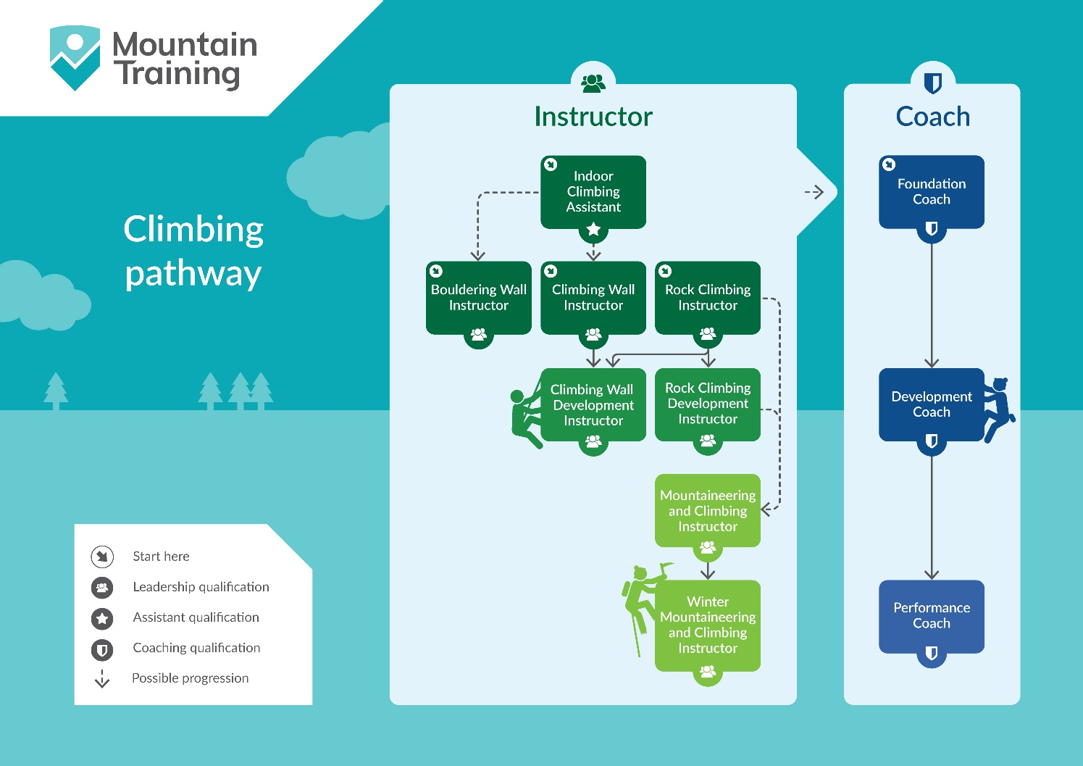

**Insurance**

Mountain Training recommends that you consider personal accident and cancellation insurance. If you already have insurance cover, check that it covers you for the activity you are undertaking.

**Partnerships**[Mountain Training Association](http://www.mountain-training.org/associations/mountain-training-association) - The Mountain Training Association is a membership community that provide members with support and development opportunities, mentoring, resources, workshops and events to help those working towards their qualification, and keep skills and knowledge current for those already qualified.

[British Mountaineering Council](https://www.thebmc.co.uk/bmc-memorandum-and-articles-of-association) - The British Mountaineering Council (BMC) is the national representative body for England and Wales that exists to protect the freedoms and promote the interests of climbers, hill walkers and mountaineers.